Name : Fariha Arai

AF ID : AF0443236

Lab 11

1. Write a Python program to handle a ZeroDivisionError exception when dividing a number by zero.

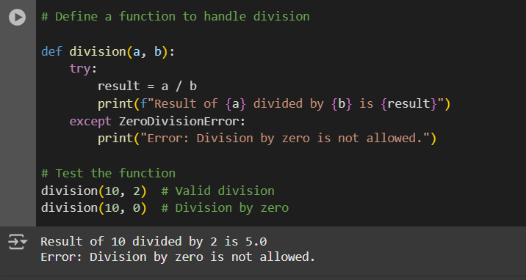

2. Write a Python program that prompts the user to input an integer and raises a ValueError exception if the input is not a valid integer.

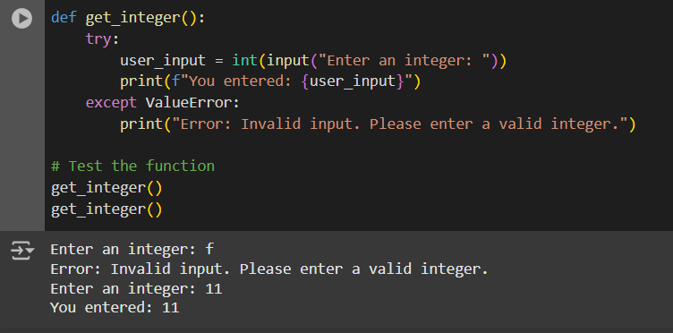

3. Write a Python program that opens a file and handles a FileNotFoundError exception if the file does not exist.

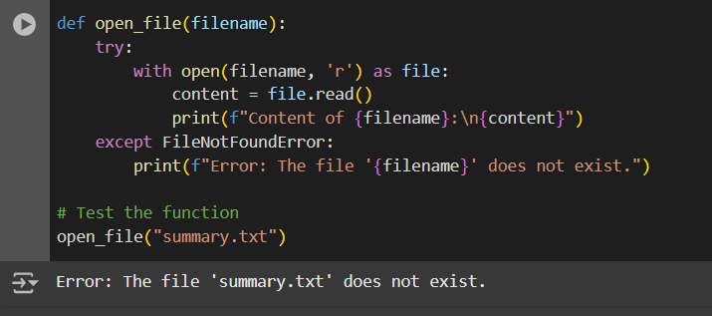

4. Write a Python program that prompts the user to input two numbers and raises a TypeError exception if the inputs are not numerical.

